**Plastic And Other Waste To Energy Systems**

**Introduction**

The exponential increase in mankind’s population over the last 200 years has increased our demands for resources in our only limited planet earth. One of our most popular and growing in demand resource are plastics, however the more resources we use, the more waste we produce. Our festering plastic waste problem only becomes larger as time goes on. In this case study I would like to explore deeper into our problem with plastics, potential solutions and what we are doing right now to combat this problem. Incineration is one of the methods used to dispose of waste plastic and we’ll be getting into that later on.

**Challenge**

The main problem with plastic waste is its future, whichever way we roll the dice we’ll always end up moving it to landfills or burning it, most plastics are not biodegradable. The plastic bags we use every can take from 10 to 1000 years to decompose and plastic bottles can take up to 450 years or even more (Rick, 2019). There has been extensive research in this field and still there is an ever-growing concern amongst researchers, this case study concerns the end life cycle of plastics and attempts to describe this problem and shed more light onto the solutions and current developments in the world surrounding this problem.

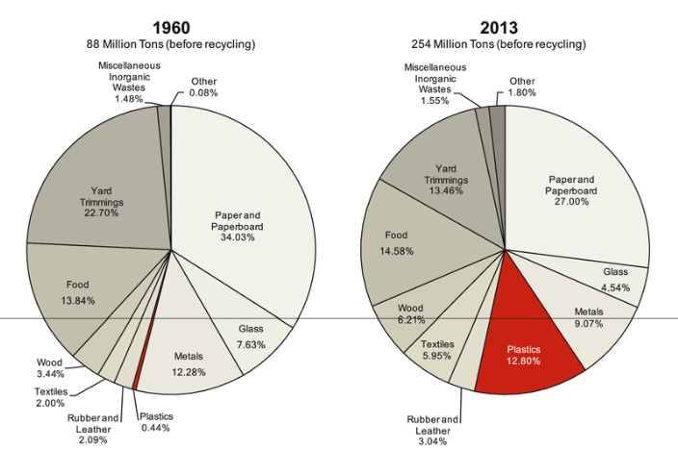

**Figure 1** Comparison of the types and amounts of MSW generated in the USA in 1960 and 2013. (Rudolph et al, 2017, p.7)

Figure 1 shows the increase in MSW(Municipal solid waste), the EPA (United States Environmental Protection Agency) defines it by the following statement *“waste consisting of everyday items, used and then thrown away, such as product packaging, bottles, food scraps and newspapers which comes from homes, schools, hospitals and businesses.”* The highlighted red section of the pie chart represents the increase in amount of plastics to 12.8% in 2013 from 0.44% in 1960 – a substantial 7900% increase in plastic waste. The population in 1960 for the United States was around 180 million and has almost doubled to a current of 328 million with only an 82% increase, comparing this to the increase in waste plastic brings about many concerns for the US, and this trend can be seen in many other countries around the world.

**Method**

Our method to combat this problem was lightly introduced previously, this was the incineration of plastics. Many plastics usually cannot be recycled or reused so they are burned, burning plastics creates high thermal energy which can be utilized by special incinerators which all operate under a standard combustion process. We can optimize these processes by extracting and using the thermal energy given off by the combustion process, we call this energy recovery – this simply means conserving the “waste energy” for another process.

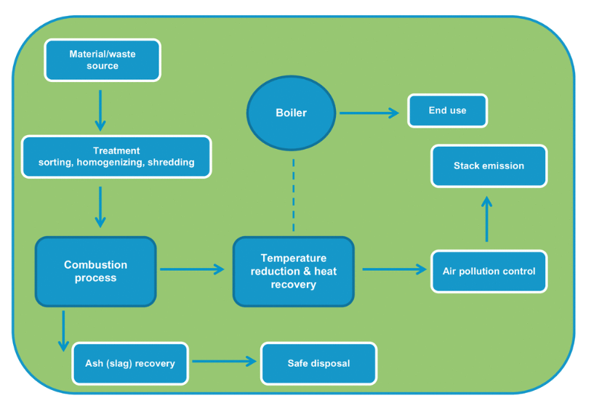

**Figure 2**. Schematic flow chart of typical incineration plant (Al-Salem et al, 2019, p50)

**Figure 2** shows a flow chart for the typical incineration plant, the first process is usually treatment – making sure materials and waste are sorted by their thermal properties. Materials with similar melting points are burned together. A standard combustion process is carried out and the results are high levels of heat and ash. The ash is safely disposed of; however the thermal energy is going through a process called heat recovery in which the energy is transferred from the combustion process to a boiler. The thermal energy is used to heat up water, this results in efficient energy recovery and safe disposal of waste products (Ash). This is one of the common methods of incineration and the energy recovery systems found within one, note that the energy recovery system utilises the by-product of the combustion processes.

**Results**

**Figure 1.1.** Volume of waste for energy generating incineration plants in England from 2000/01 to 2018/19 (Statisa, 2020)

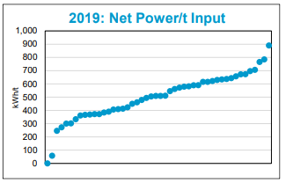

**Figure 1.2.** Net power exported per tonne of input (Tolvik Consulting, Uk Energy from Waste statistics, 2019, p8.)

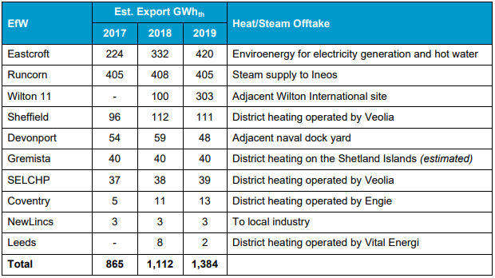

**Figure 1.3.** EfWs exported heat for beneficial use. (Tolvik Consulting, Uk Energy from Waste statistics, 2019, p8)

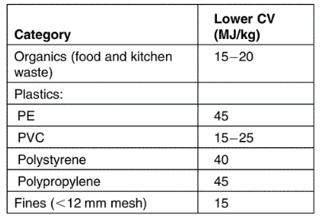

**Figure 1.4.** Waste Definition and Classification Based on Point of Origin and Source (Al-Salem et al, 2019, p.48**)**

**Evaluation**

I would like to first discuss incineration regarding the environmental effects, the incineration process releases many harmful gasses naturally as burning various kinds of material give of different products. The incineration process is designed to control and monitor pollution to minimise environmental damage, this can only be done for so long as the pollution will still build up in the atmosphere which is a growing problem in and of itself. The burning of plastics however does destroy some harmful blowing agents, chemical additives, granules, and foams. (Al-Salem et al, 2019, p59)

There are guidelines that control the burning of plastics, plastics are regarded as HSV (Higher Calorific Value) which simply means they contain high energy levels and give off a stronger exothermic reaction than most other materials. Burning plastics alone is harmful and not efficient so the introduction of LCV (Lower Calorific Value) materials into the feedstock is essential to ensure if burning plastics is done, it will be alongside disposing other materials too. In **Figure 1.4** you can see the calorific values of different kinds of MSW. Lower CV materials are mixed in with plastics to justify the burning of plastic – this is a requirement for feedstock to be considered for incineration.

**Figure 1.1** highlights the increase in volume of waste that is used in energy generating incineration plants, this is a huge step forward, from 2001/01 to 2018/19 we’ve seen a 361% increase in waste being used to produce energy in England. Moving onto the next two key results, **Figure 1.2 and Figure 1.3** We can see the increase in power generation and how that has been effective in distributing the energy to processes where it was necessary. In 2017 the estimated average export of GWhth is 865, this increase by 60% to a total of 1,384 in 2019 which was used in various industrial processes and heating in residential districts.

The incineration of plastics and other MSW is a good way of producing energy and contributes to solving our plastic problem, disposing of plastic creates energy and saves our environment from plastics. This technology has its limitations of course, burning materials is not a long-term solution for most materials, producing harmful gasses by burning these materials can only be controlled so much as previously stated.

**Reference List:**

Al-Salem, S. M.. (2019). Plastics to Energy - Fuel, Chemicals, and Sustainability Implications. (pp. 48, 50). Elsevier. Retrieved from  
https://app.knovel.com/hotlink/toc/id:kpPEFCSI04/plastics-energy-fuel/plastics-energy-fuel Accessed, 22nd November 2020

Rick Leblanc, 2019, The Decomposition of Waste in Landfills, Available from: <https://www.thebalancesmb.com/how-long-does-it-take-garbage-to-decompose-2878033>. Accessed: 22nd November 2020

Rudolph, Natalie Kiesel, Raphael Aumnate, Chuanchom. (2017). Understanding Plastics Recycling - Economic, Ecological, and Technical Aspects of Plastic Waste Handling - 1.1 Municipal Solid Waste - A Daily Companion. (pp. 1). Hanser Publishers. Retrieved from  
<https://app.knovel.com/hotlink/pdf/id:kt011F0JB6/understanding-plastics/municipal-solid-waste> Accessed, 22nd November 2020

Tolvik Consulting Ltd, (2020). Uk Energy from Waste Statistics – 2019. (pp. 8). Available from: <https://www.tolvik.com/wp-content/uploads/2020/05/Tolvik-UK-EfW-Statistics-2019-Report-June-2020.pdf> , Accessed, 22nd November 2020